Structural and functional annotation of the rhizosphere microbiome of soybean under induced drought stress

Mbongeni T.B. Nkolisa, Ayansina S. Ayangbenro and Olubukola O. Babalola*
Food Security and Safety Focus Area, Faculty of Natural and Agricultural Sciences, North-West University, Mmabatho 2735, South Africa.

Corresponding Author: olubukola.babalola@nwu.ac.za

- Supplemental material

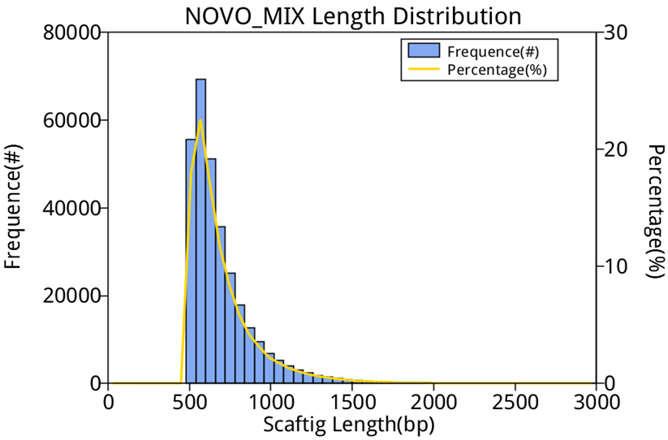Figure A1:Distribution of scaftig length (>=500bp) of all the 16 sample used in the study. The study featured two soybean genotypes RA 4818R which is drought tolerant and SSS 5449 known to be drought susceptible.

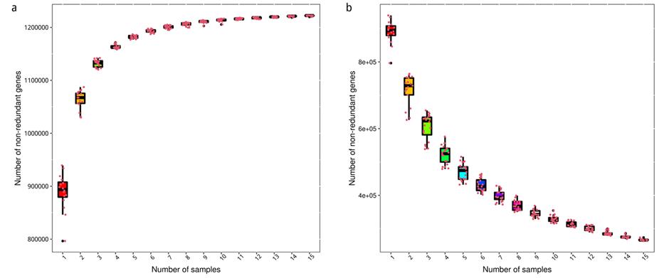
Figure A2: Rarefaction curves plotted with the number of abundant core-genes from the abundance table and pan-genes separately by randomly drawing sampling.
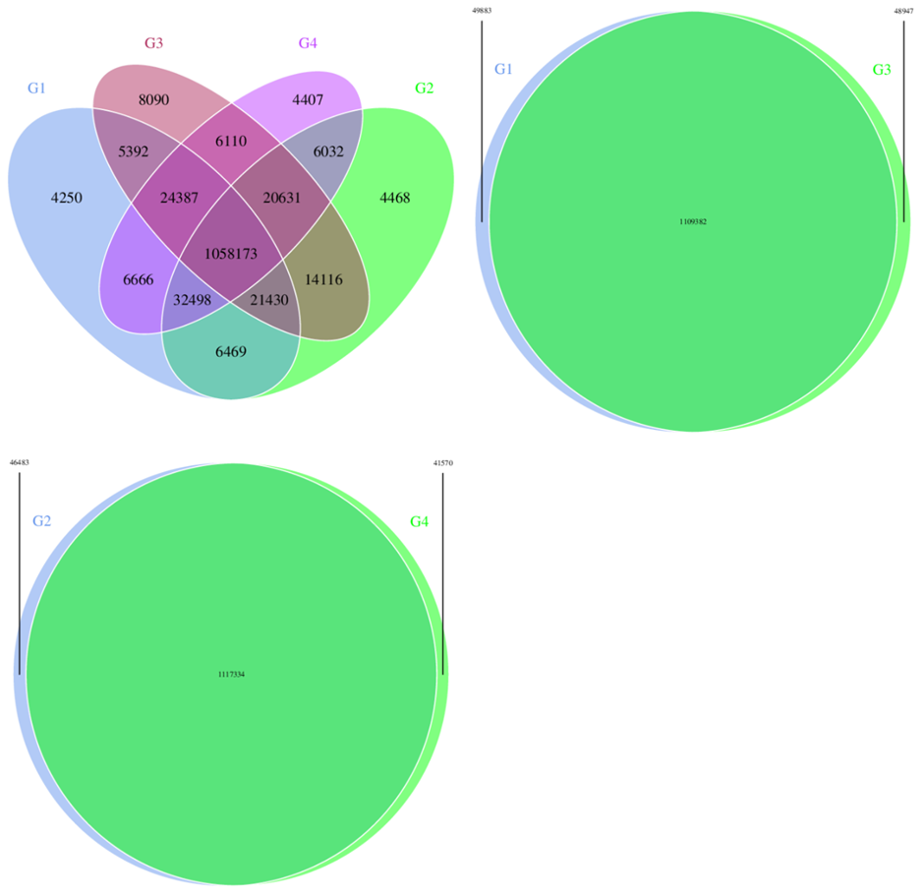
Figure A3: Venn figures for gene number among samples. The overlap parts represent the number of common genes between/among samples (groups); the other parts represent the number of special genes of samples (groups).
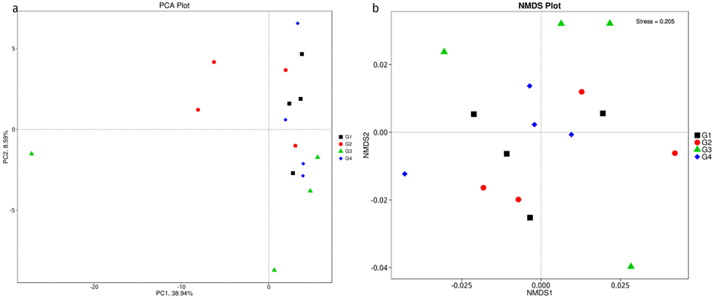
Figure A4: PCA and NMDS analysis in phylum.
PCA: X-axis is the first principal component; Y-axis is the second principal component. The percentage stands for the contribution of the principal components to the variation in samples. Each point in the graph stands for a sample. Samples belong to the same group that are in the same color. NMDS: NMDS reflects the pairwise dissimilarity between objects in a low-dimensional space. Samples belonging to the same group are in the same color. When the value of Stress factor is less than 0.2, it is considered that NMDS is reliable to some extent.

Table1: Soil analysis results for the bulk soil used in the greenhouse experiment for 8 weeks
Analyte | Units
Organic Matter | 1.08%
Exchangeable Acidity | 0.77%
NH₄⁺ | 7.38 mg/kg
NO₃ | 4.38 mg/kg
SO₄ ²⁻ | 12.3 mg/kg
Clay | 20 %
Sand | 76 %
Silt | 4 %
Ca | 1 980.00 mg/kg
Ca | 9.88 cmol⁺/kg
Mg | 432 mg/kg
Mg | 3.56 cmol₊/kg
Na | 79.6 mg/kg
Na | 0.35 cmol⁺/kg
K | 227 mg/kg
K | 0.58 cmol⁺/kg
P | 5.12 mg/kg
pH | 6.93
Total N | 0.02 %

The soil pH was relatively neutral at 6.98. The organic matter content of the soil was 1.08%. The calcium (Ca) content is 1980 mg/kg (9.88 cmol+/kg). The magnesium (Mg) value is 432 mg/kg (3.56 cmol+/kg). Sodium (Na) is at 79.6 mg/kg (0.35 cmol+/kg). The sulfate concentration is 12.3 mg/k; the sulfate is important for plant development and protein synthesis. The soil texture is mainly sand (76%); 20% is clay, and 4% is silt. The phosphorus (P) value is 5.12 mg/kg. The soil pH was 6.93, slightly acidic to neutral, and generally suitable for most crops. The soil's total nitrogen was 0.02%
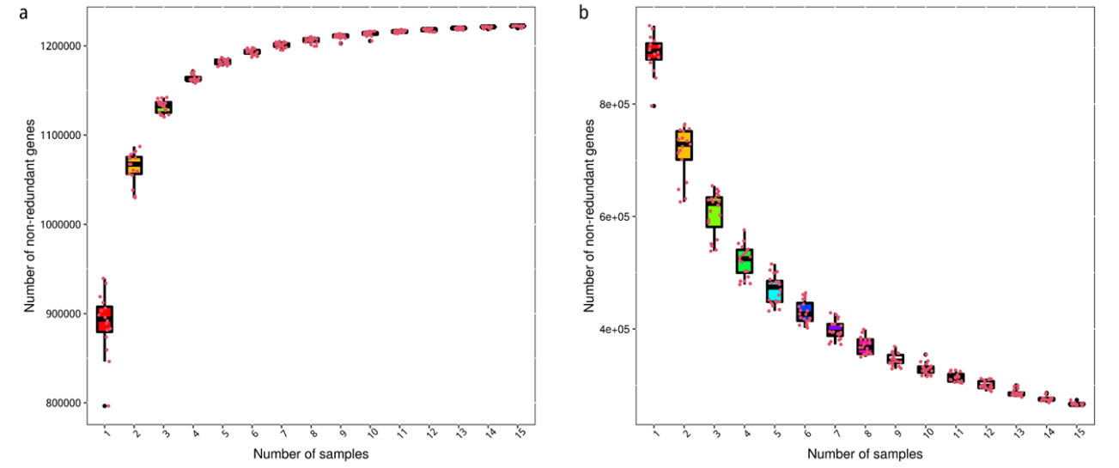
Figure A5:Core-pan gene rarefaction curve.
Plot A illustrates the pan genome rarefaction curve and Plot B illustratesCore genome rarefaction curve. In figure , X-axis means the number of samples that sampled and the Y-axis means the gene number.

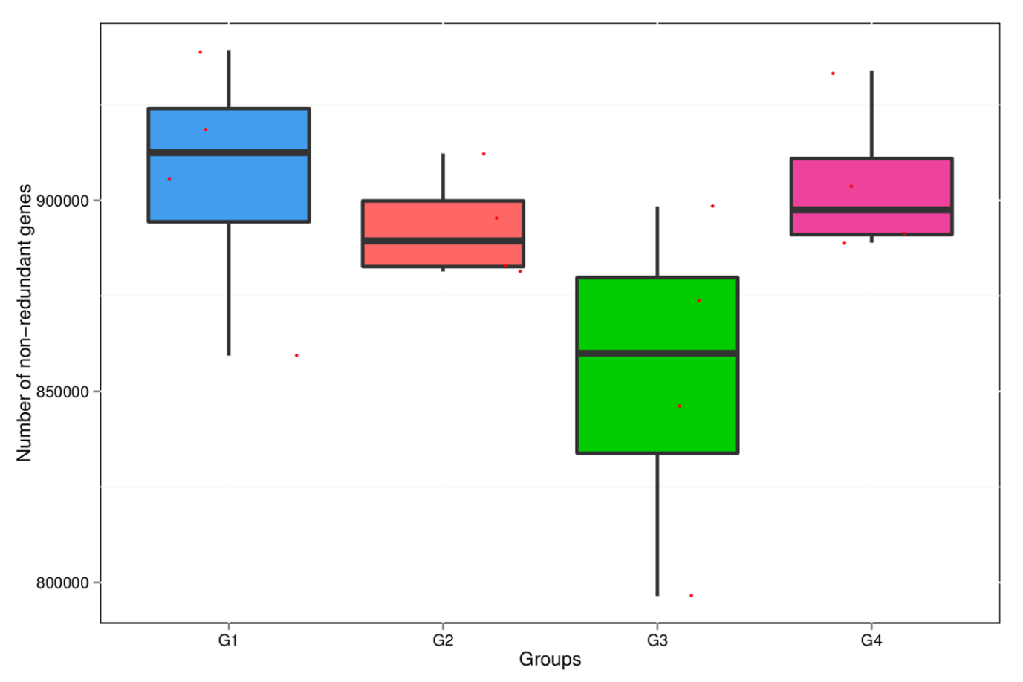
Figure A6: Gene number of different groups. The X-axis indicates the group information and Y-axis indicates the gene number.

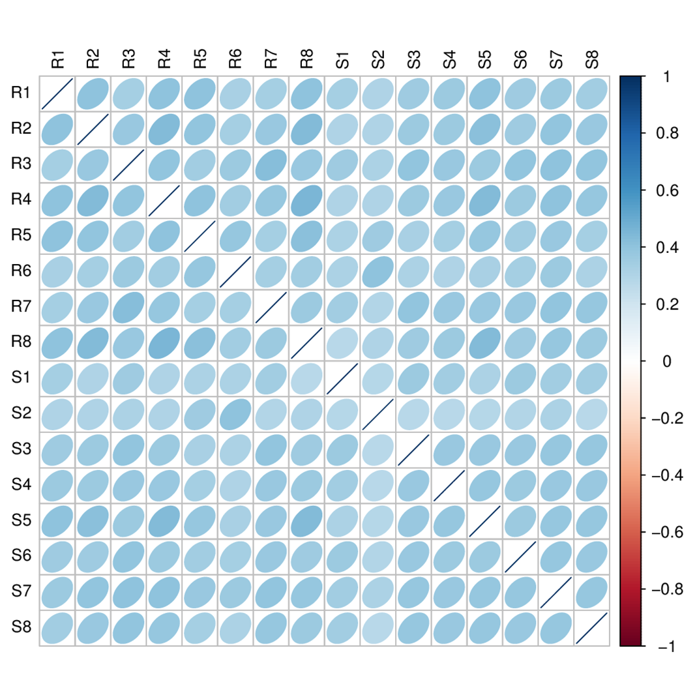
Figure A7: Correlation between samples. The blue bubbles mean positive correlation. Red bubbles mean negative correlation. The deeper the color is, the greater the association is between the samples of the 2 soybean genotypes and experimental and control groups.

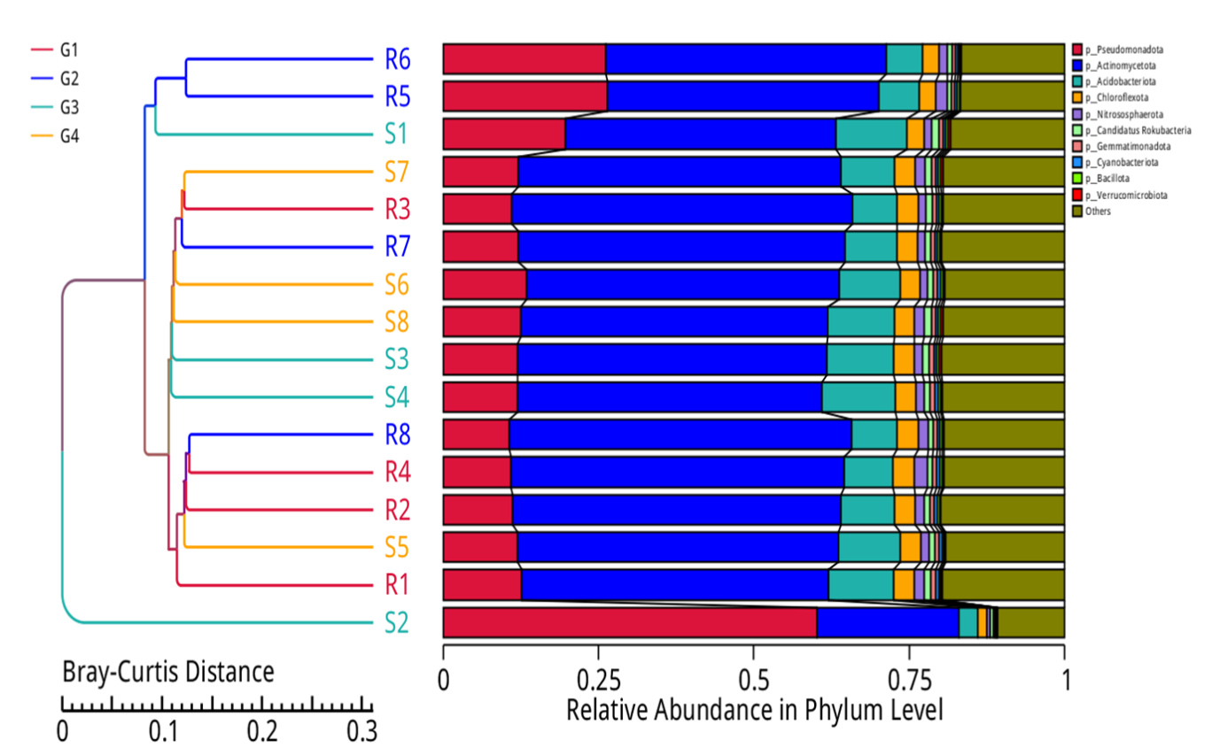
Figure A8:Clustering tree based on Bray-Curtis distance. To evaluate the similarity of samples. The distance was calculated according to relative taxonomic abundance. And the final results were exhibited by combining the clustering result and relative abundance of different samples in phylum level.

